Execution Proof Document

Data Lake Analytics

1. Introduction
This document provides execution evidence and project results for the Data Lake Analytics Solution built using Azure Data Factory (ADF) and Azure Data Lake Storage (ADLS).
The objective is to demonstrate:
The successful end-to-end execution of ETL pipelines in ADF.
The organization of data across Bronze, Silver, and Gold layers in ADLS.
The validation of transformations and schema consistency.
The readiness of curated data for downstream analytics and reporting.

2. Project Architecture
The architecture follows a multi-layered data lake design:
Bronze Layer: Stores raw ingested data.
Silver Layer: Contains cleaned and transformed data.
Gold Layer: Holds curated, analytics-ready tables (fact and dimension data).

3. Environment Setup Evidence
The environment was successfully set up in Azure, including:
- A Resource Group for project resources.
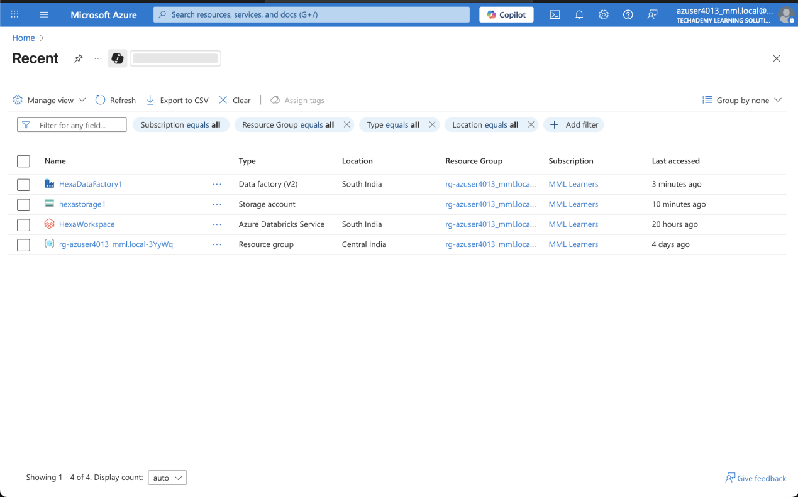
- An ADLS Gen2 account with bronze, silver, and gold containers.
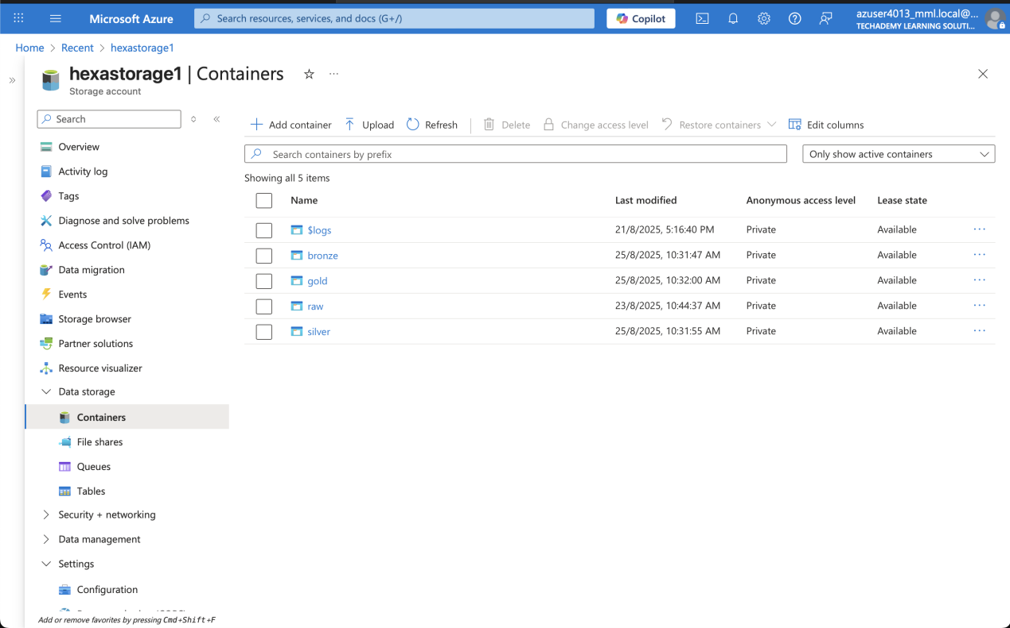

- An ADF workspace configured with Managed Identity for secure access.
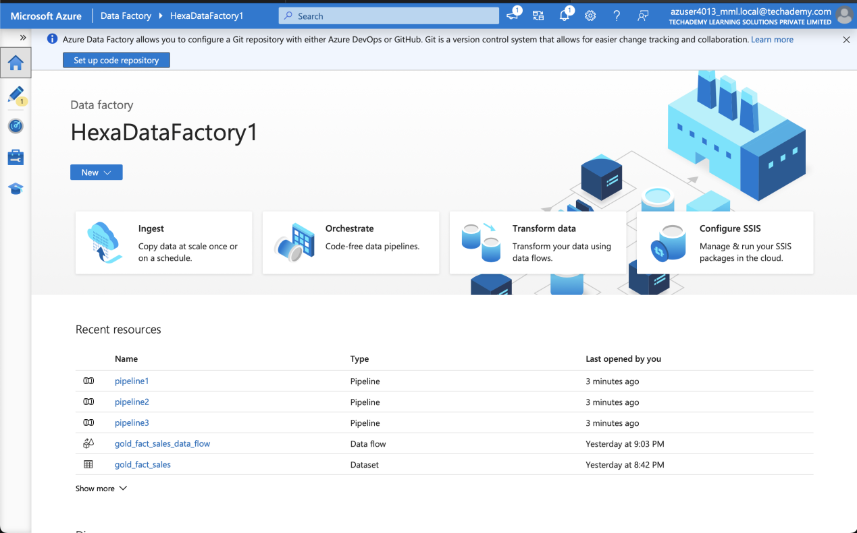

4. Data Ingestion (Bronze Layer)
Raw data was ingested from source files into the Bronze container using ADF Copy Activity pipelines. Monitoring results confirm successful execution.
- ADF Copy Activity pipeline (Designer view)
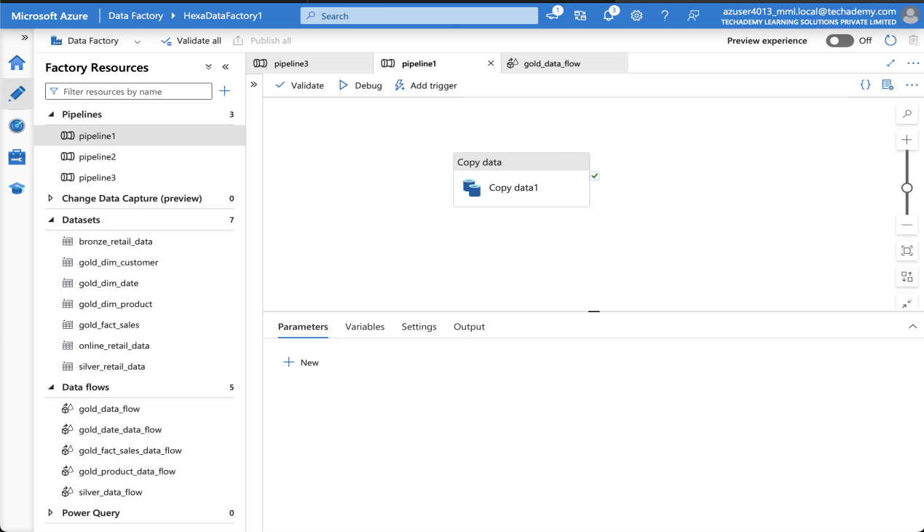
- Monitoring tab showing successful pipeline run

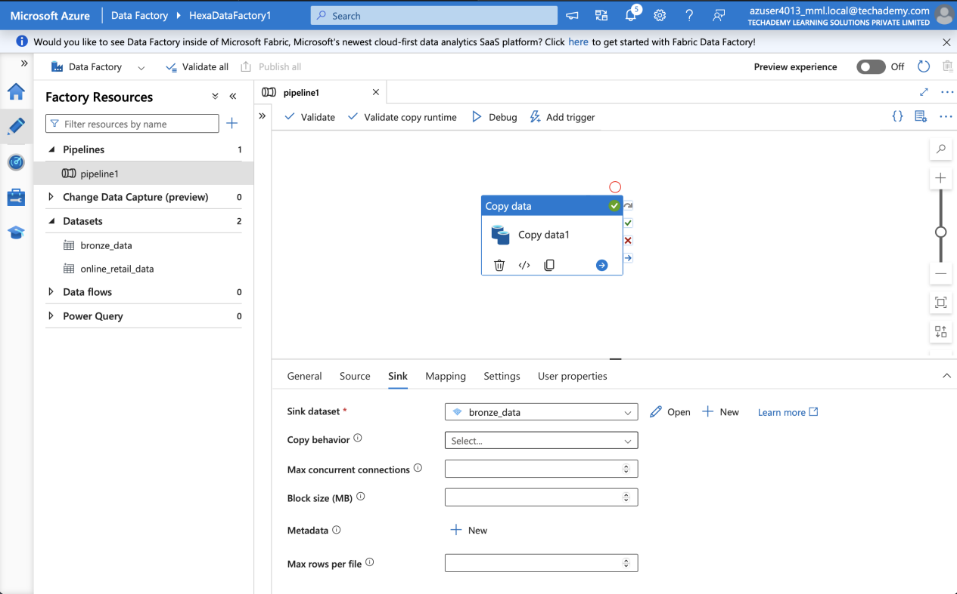
- ADLS Bronze container showing ingested files

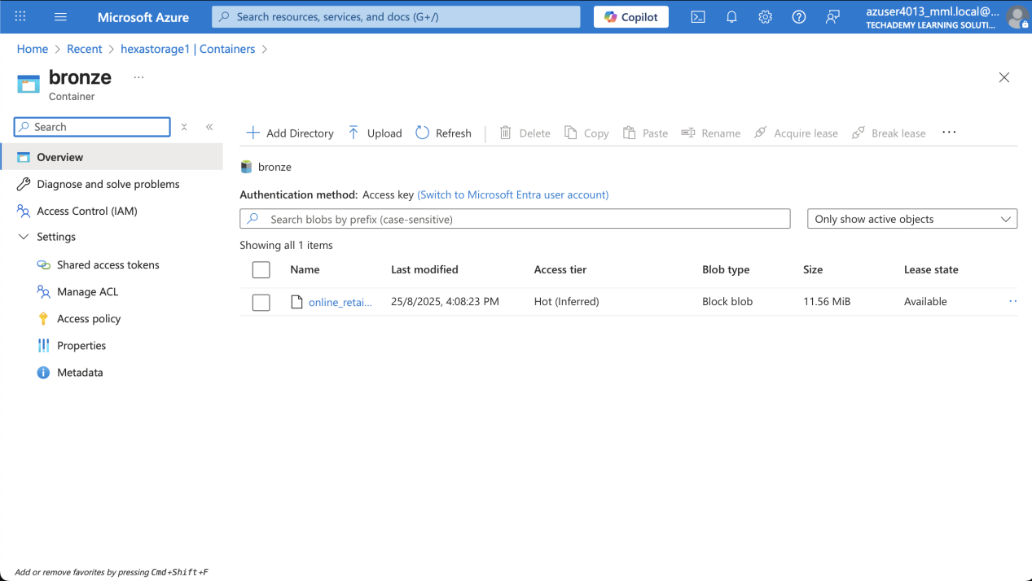

5. Data Transformation (Silver Layer)
Data was transformed in ADF Mapping Data Flows, including:
- Removing null/duplicate records.
- Standardizing date and numeric formats.
- Creating derived attributes.
- The transformed data was stored in the Silver container.
- ADF Mapping Data Flow (showing transformations: removing nulls/duplicates, derived columns)
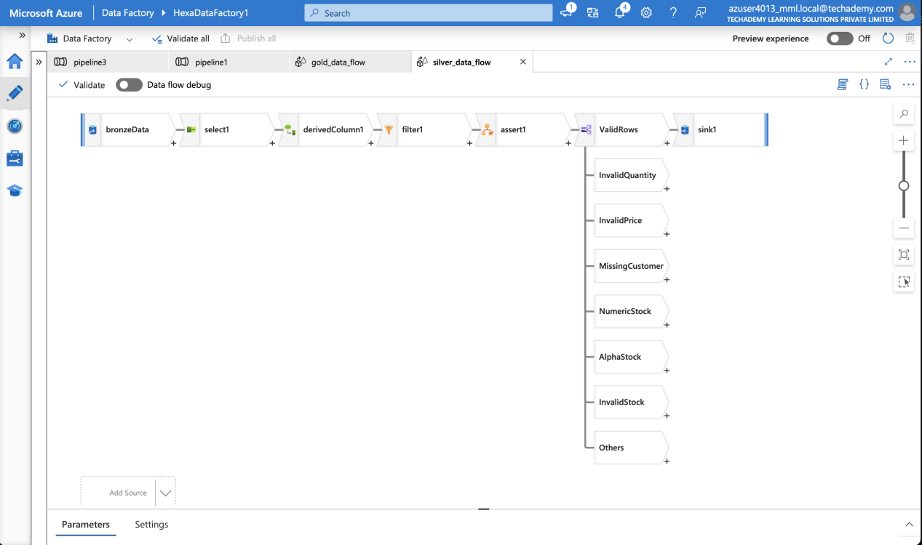
- Pipeline execution success in Monitoring tab
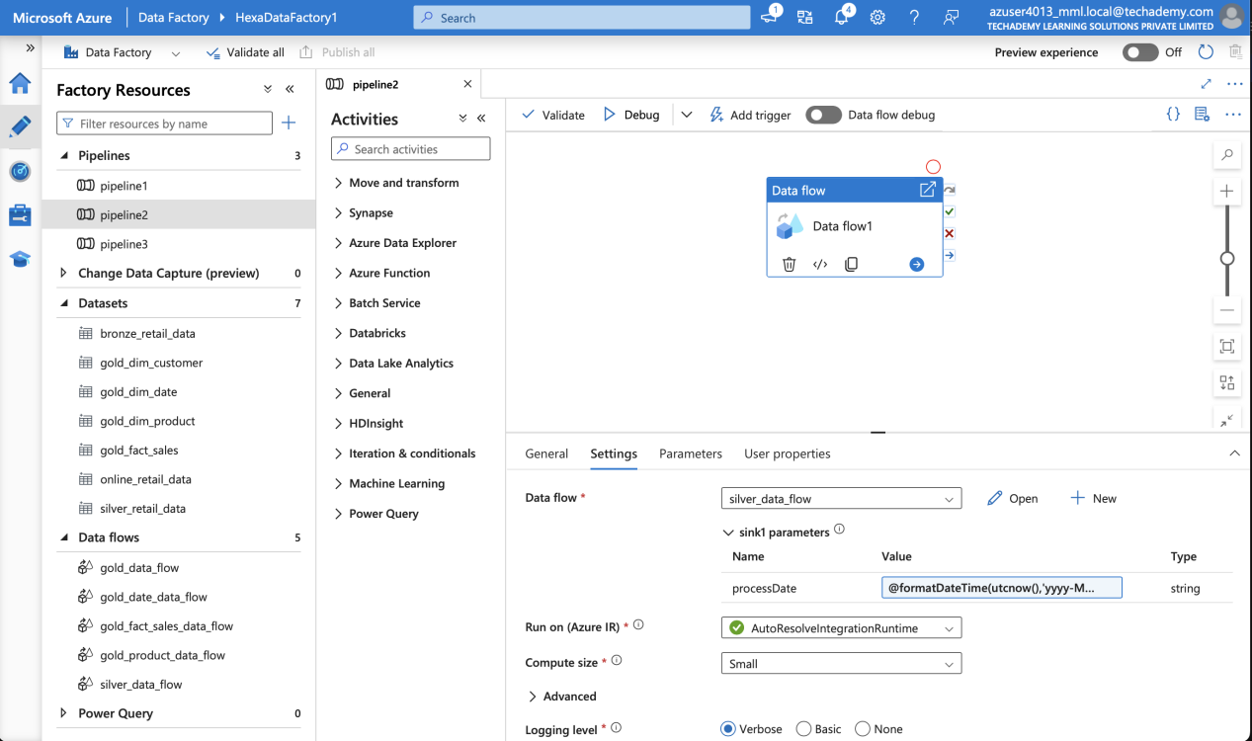
- ADLS Silver container with transformed files
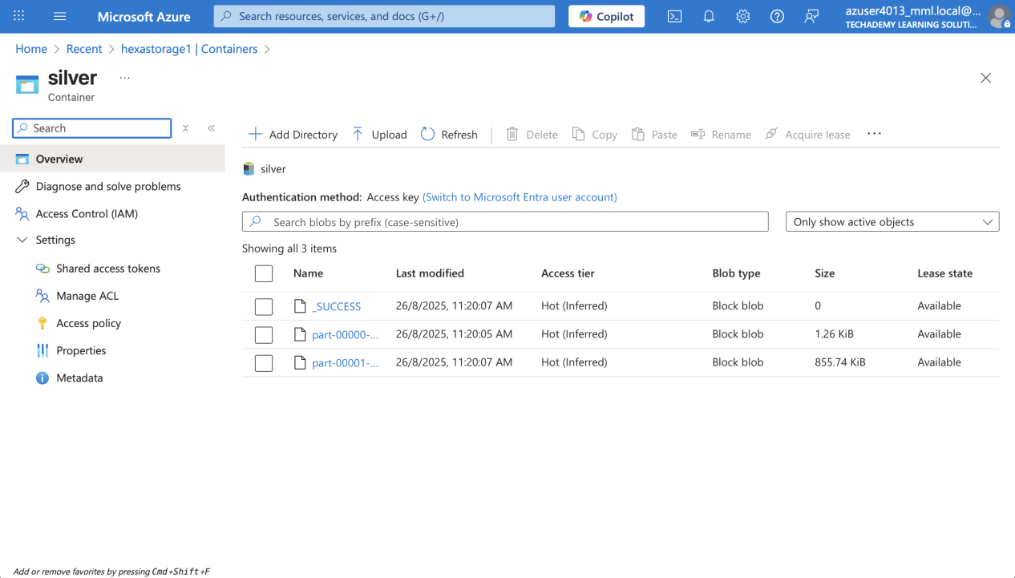

6. Curated Data (Gold Layer)
Curated tables were created and stored in the Gold layer. These include:
- Dimension tables: Customer, Product, Date.
- Fact table: Sales (linked with surrogate keys).
This structured data is now analytics-ready.
- ADF pipeline creating dimension and fact tables
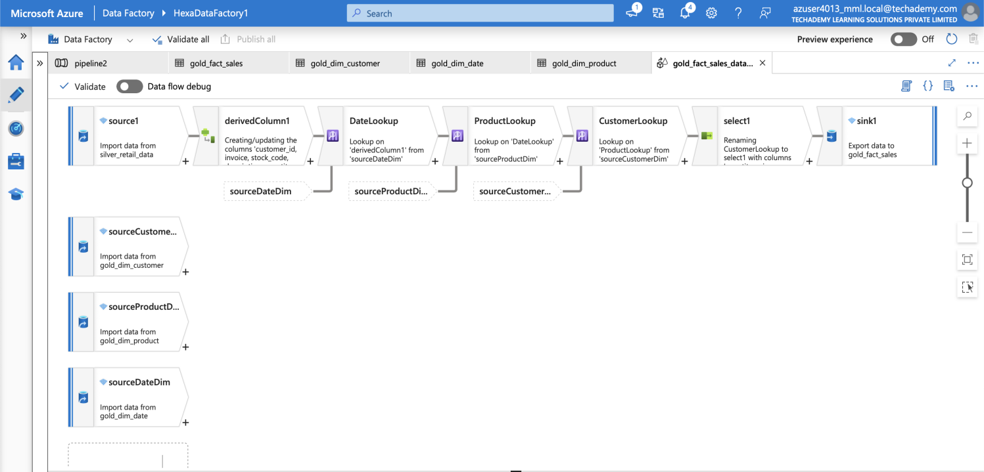
- ADF Gold product Data flow:
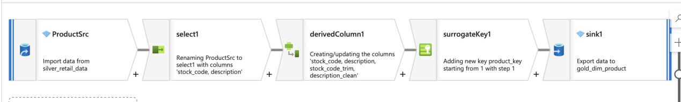
- ADF Gold Customer Data flow:
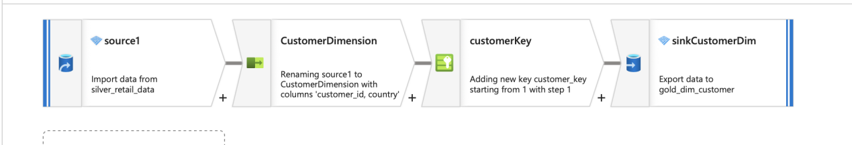
- ADF Gold Date data flow:
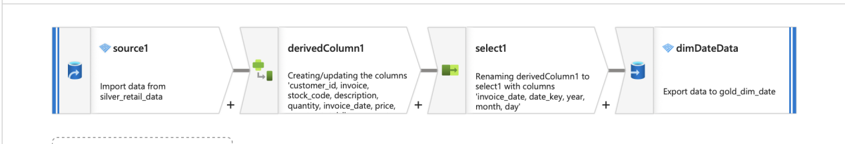
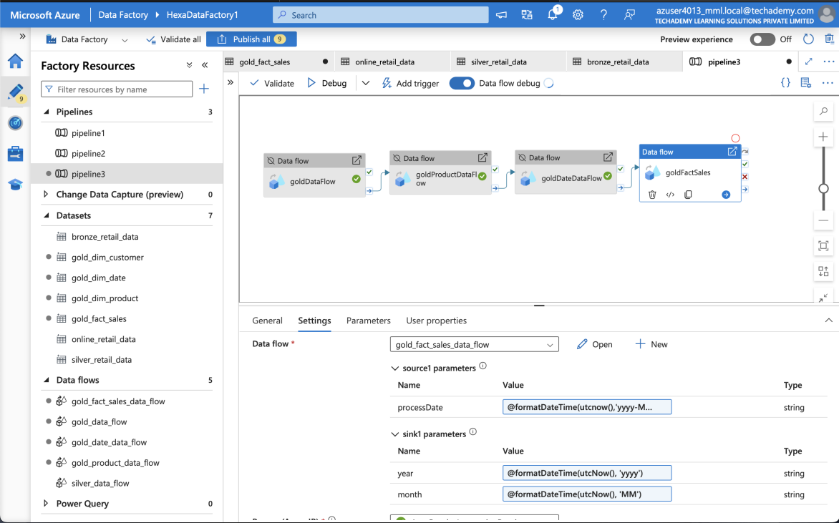
- ADLS Gold container with structured files
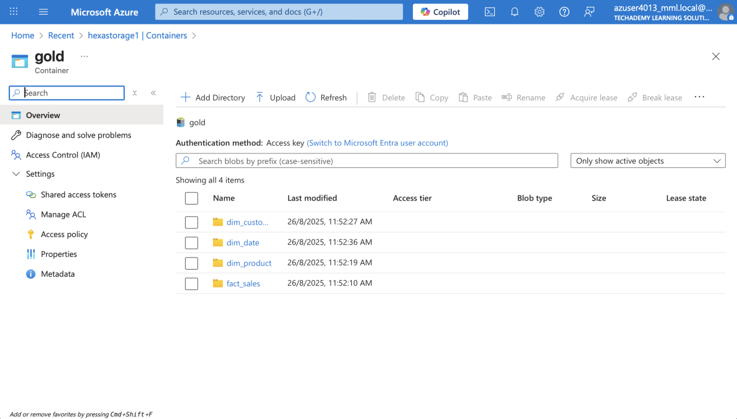

7. Validation & Outputs
Validation checks confirmed:
- Correct record counts between source and target.
- Schema alignment after transformations.
- Clean and structured data in the Gold layer, ready for reporting.
- Bronze/ Original data schema:
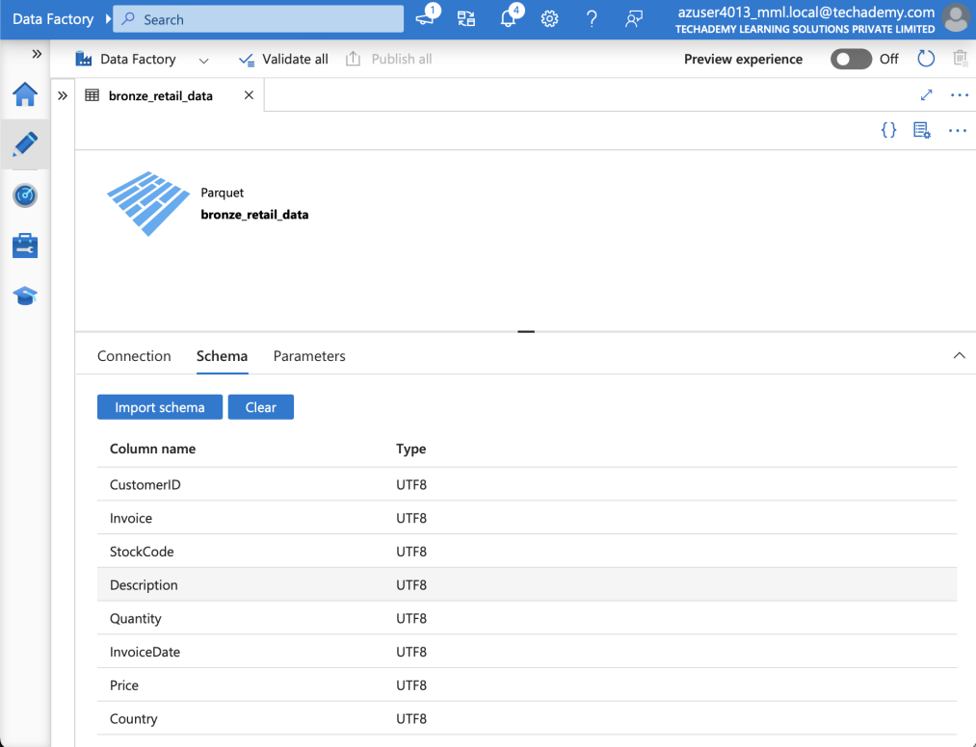
- Silver data Schema:
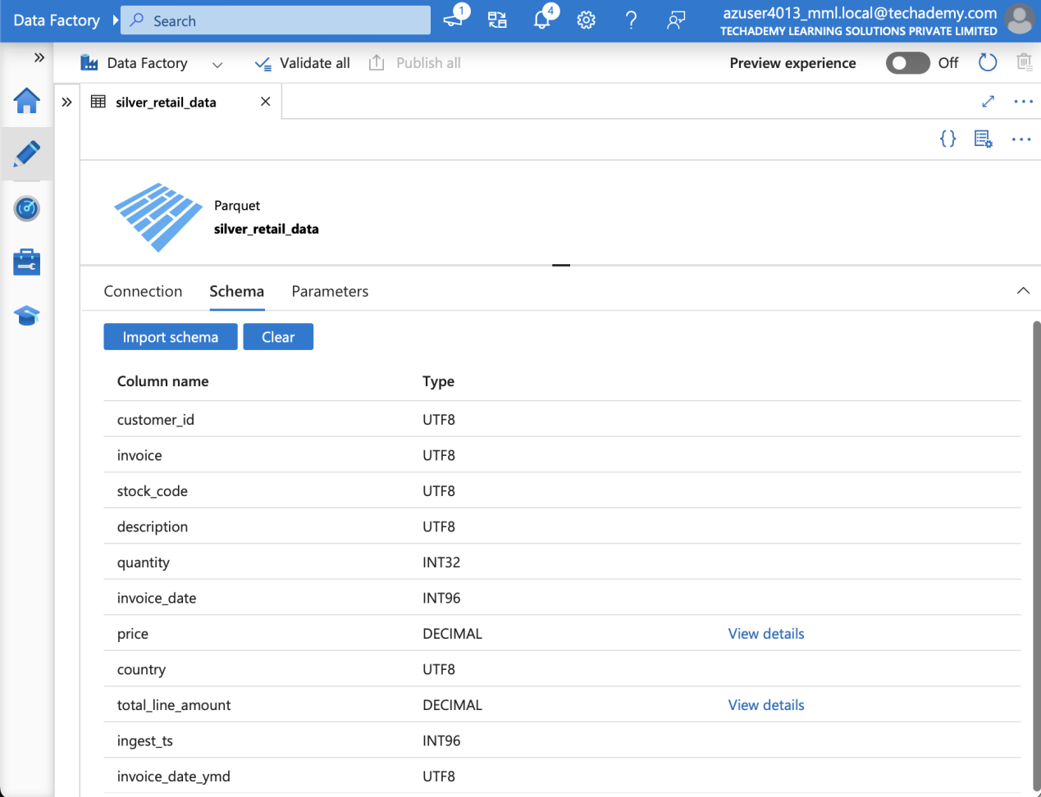
- Gold-Customer data schema:
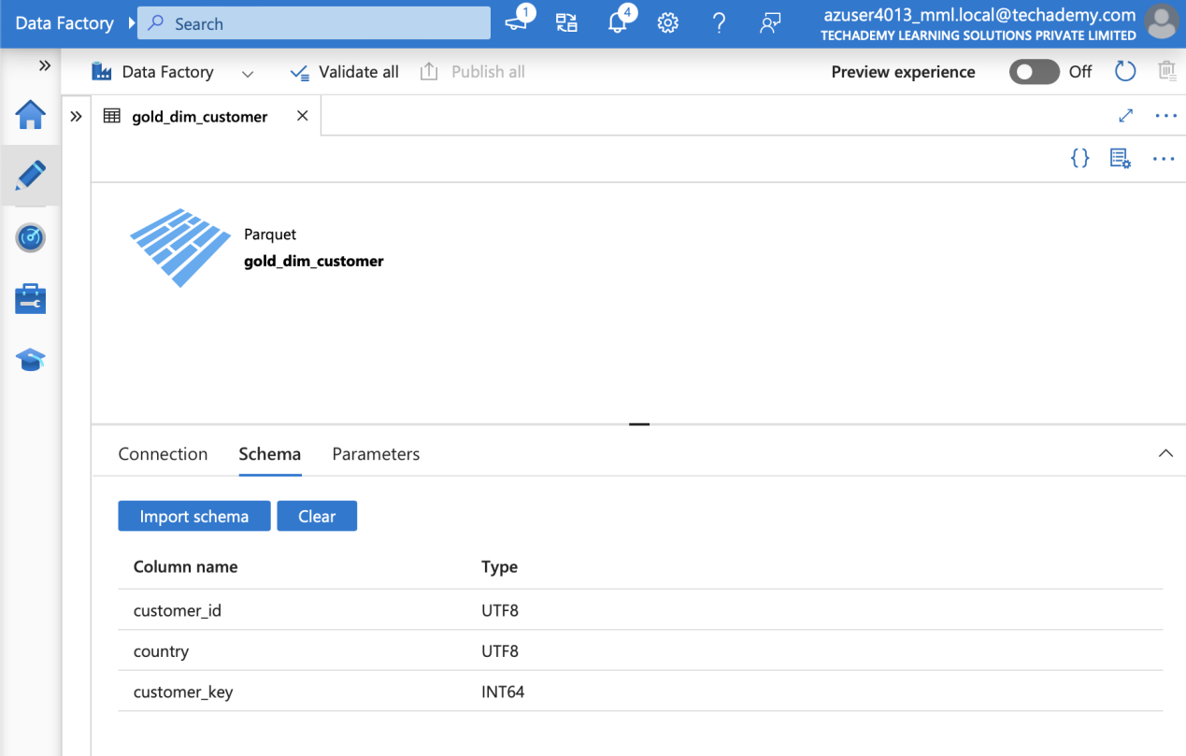
- Gold-Product data Schema:
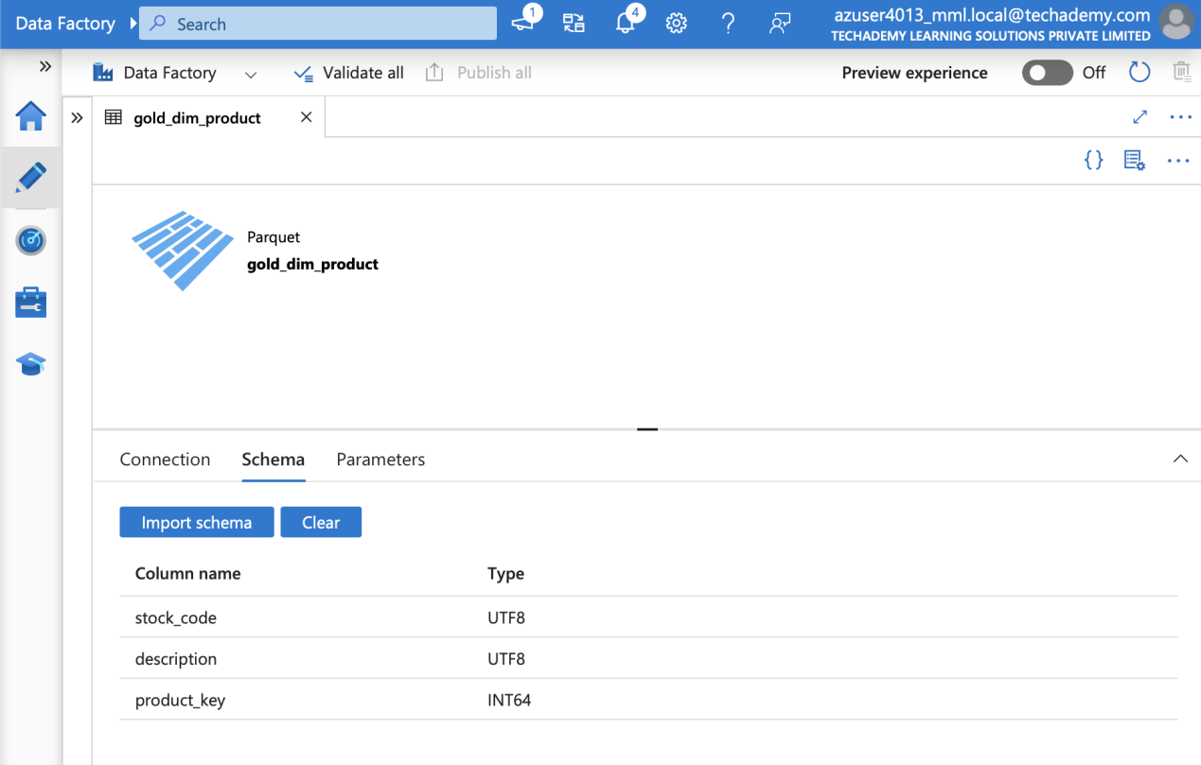
- Gold-Date data Schema:
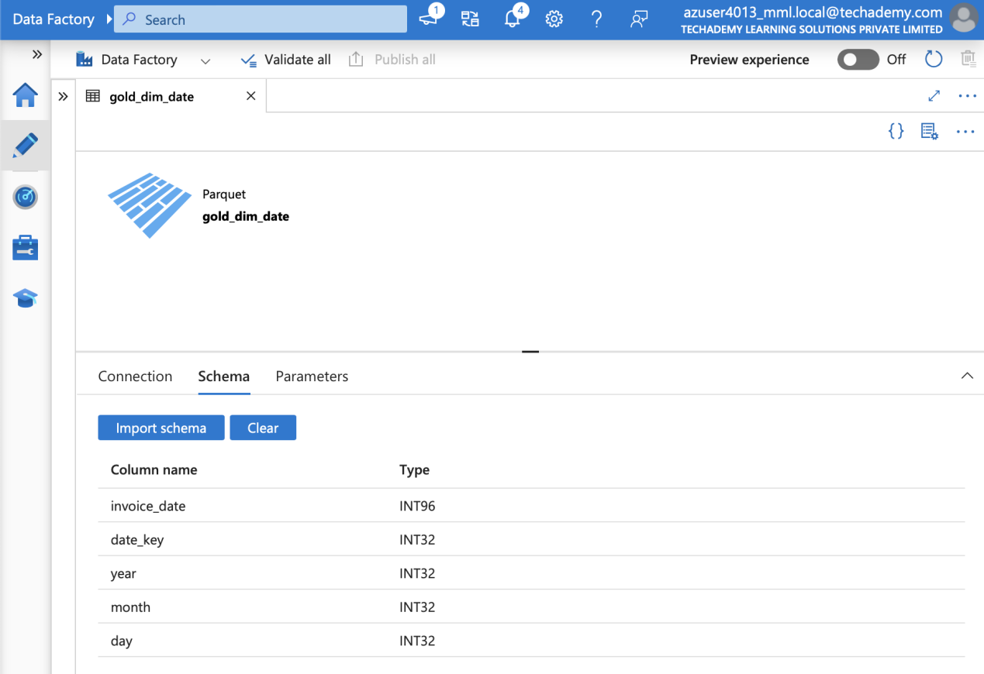

- Gold Fact table Schema:
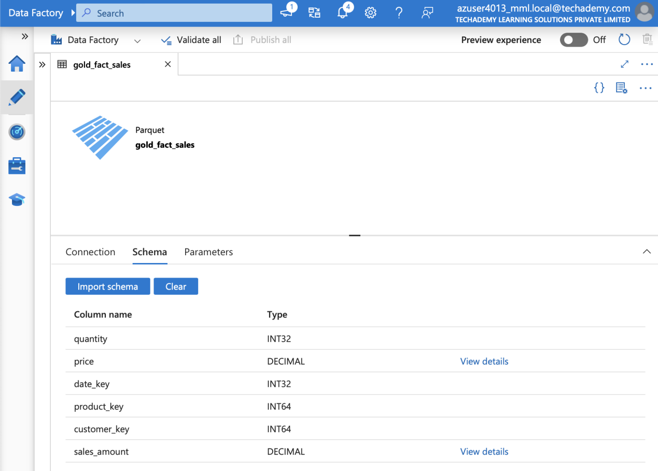

8. Summary & Conclusion
The project successfully demonstrated the implementation of a multi-layered data lake architecture using ADF and ADLS.
All pipelines executed successfully, moving data from Bronze → Silver → Gold.
Validation outputs confirm correctness and consistency.
The Gold layer now provides curated data for business analytics.

